# Assignment 2

## Tasks:-

1. Download the dataset: Dataset
2. Load the dataset.
3. Perform Below Visualizations.

* Univariate Analysis
* Bi - Variate Analysis
* Multi - Variate Analysis

1. Perform descriptive statistics on the dataset.
2. Handle the Missing values.
3. Find the outliers and replace the outliers
4. Check for Categorical columns and perform encoding.
5. Split the data into dependent and independent variables.
6. Scale the independent variables
7. Split the data into training and testing

# Mounting Drive for dataset

In [ ]:

**from** google.colab **import** drive

drive**.**mount('/content/drive')

# Importing libraries

In [15]:

**import** pandas **as** pd

**import** numpy **as** np

**import** matplotlib.pyplot **as** plt

**import** seaborn **as** sns

**from** sklearn.preprocessing **import** LabelEncoder,MinMaxScaler

**from** sklearn.model_selection **import** train_test_split

Downloading and Importing the Dataset

In [3]:

data **=** pd**.**read_csv('/content/drive/MyDrive/IBM/Churn_Modelling.csv')

data **=** data**.**iloc[:,3:]

data

Out[3]:

|  | **CreditScore** | **Geography** | **Gender** | **Age** | **Tenure** | **Balance** | **NumOfProducts** | **HasCrCard** | **IsActiveMember** | **EstimatedSalary** | **Exited** |
| --- | --- | --- | --- | --- | --- | --- | --- | --- | --- | --- | --- |
| **0** | 619 | France | Female | 42 | 2 | 0.00 | 1 | 1 | 1 | 101348.88 | 1 |
| **1** | 608 | Spain | Female | 41 | 1 | 83807.86 | 1 | 0 | 1 | 112542.58 | 0 |
| **2** | 502 | France | Female | 42 | 8 | 159660.80 | 3 | 1 | 0 | 113931.57 | 1 |
| **3** | 699 | France | Female | 39 | 1 | 0.00 | 2 | 0 | 0 | 93826.63 | 0 |
| **4** | 850 | Spain | Female | 43 | 2 | 125510.82 | 1 | 1 | 1 | 79084.10 | 0 |
| **...** | ... | ... | ... | ... | ... | ... | ... | ... | ... | ... | ... |
| **9995** | 771 | France | Male | 39 | 5 | 0.00 | 2 | 1 | 0 | 96270.64 | 0 |
| **9996** | 516 | France | Male | 35 | 10 | 57369.61 | 1 | 1 | 1 | 101699.77 | 0 |
| **9997** | 709 | France | Female | 36 | 7 | 0.00 | 1 | 0 | 1 | 42085.58 | 1 |
| **9998** | 772 | Germany | Male | 42 | 3 | 75075.31 | 2 | 1 | 0 | 92888.52 | 1 |
| **9999** | 792 | France | Female | 28 | 4 | 130142.79 | 1 | 1 | 0 | 38190.78 | 0 |

10000 rows × 11 columns

# Visualizations

### 1. Univariate Analysis

In [4]:

**for** col **in** data**.**columns:

**if**(data**.**dtypes[col]**==**'int64' **or** data**.**dtypes[col]**==**'float64' ):

sns**.**boxplot(x**=**data[col])**.**set( xlabel**=**col)

plt**.**show()

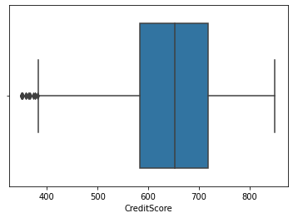

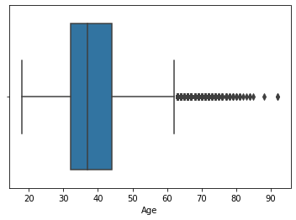

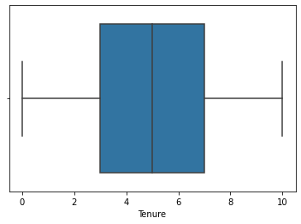

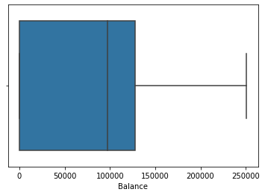

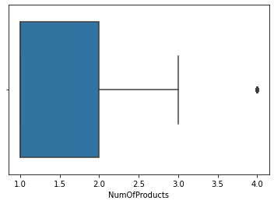

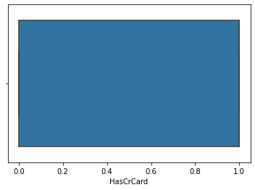

1. 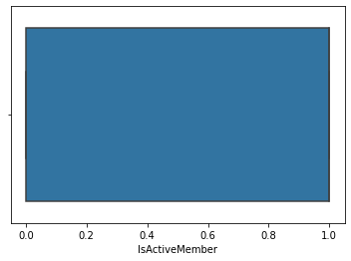

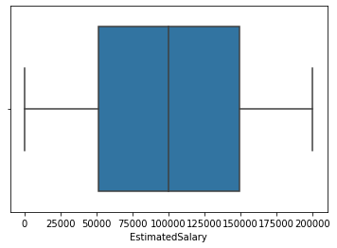

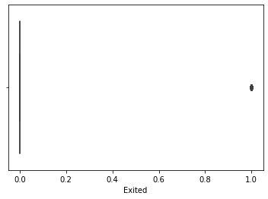

### 2. Bi-Variate Analysis

In [30]:

sns**.**FacetGrid(data,hue**=**'Exited',size**=**5)**.**map(plt**.**scatter,"Balance","CreditScore")**.**add_legend()

plt**.**show()

/usr/local/lib/python3.7/dist-packages/seaborn/axisgrid.py:337: UserWarning: The `size` parameter has been renamed to `height`; please update your code.

warnings.warn(msg, UserWarning)

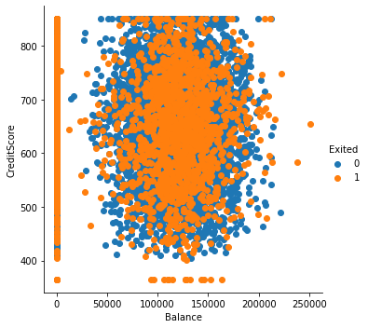

### 3.Multivariate

In [26]:

sns**.**pairplot(data, hue**=**'Exited', height**=**2)

Out[26]:

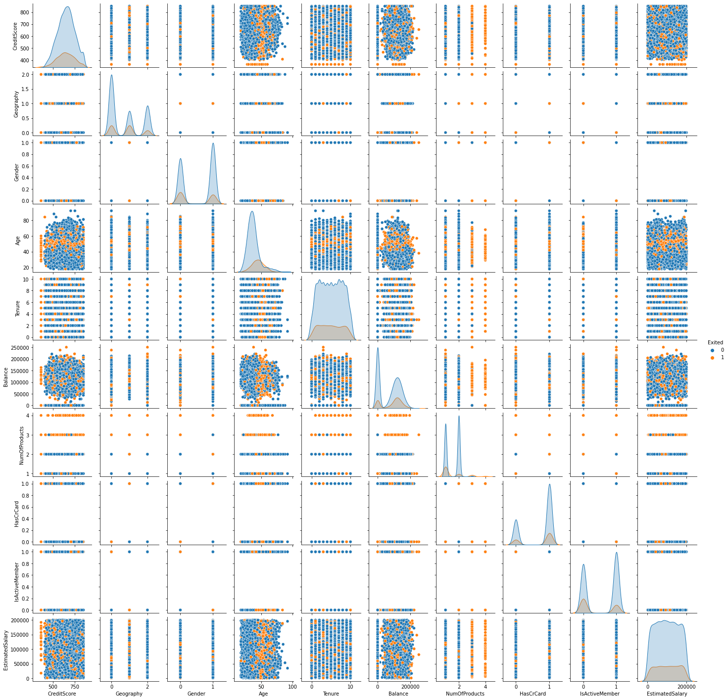

# Descriptive Analysis

In [7]:

data**.**describe()

Out[7]:

|  | **CreditScore** | **Age** | **Tenure** | **Balance** | **NumOfProducts** | **HasCrCard** | **IsActiveMember** | **EstimatedSalary** | **Exited** |
| --- | --- | --- | --- | --- | --- | --- | --- | --- | --- |
| **count** | 10000.000000 | 10000.000000 | 10000.000000 | 10000.000000 | 10000.000000 | 10000.00000 | 10000.000000 | 10000.000000 | 10000.000000 |
| **mean** | 650.528800 | 38.921800 | 5.012800 | 76485.889288 | 1.530200 | 0.70550 | 0.515100 | 100090.239881 | 0.203700 |
| **std** | 96.653299 | 10.487806 | 2.892174 | 62397.405202 | 0.581654 | 0.45584 | 0.499797 | 57510.492818 | 0.402769 |
| **min** | 350.000000 | 18.000000 | 0.000000 | 0.000000 | 1.000000 | 0.00000 | 0.000000 | 11.580000 | 0.000000 |
| **25%** | 584.000000 | 32.000000 | 3.000000 | 0.000000 | 1.000000 | 0.00000 | 0.000000 | 51002.110000 | 0.000000 |
| **50%** | 652.000000 | 37.000000 | 5.000000 | 97198.540000 | 1.000000 | 1.00000 | 1.000000 | 100193.915000 | 0.000000 |
| **75%** | 718.000000 | 44.000000 | 7.000000 | 127644.240000 | 2.000000 | 1.00000 | 1.000000 | 149388.247500 | 0.000000 |
| **max** | 850.000000 | 92.000000 | 10.000000 | 250898.090000 | 4.000000 | 1.00000 | 1.000000 | 199992.480000 | 1.000000 |

# Handling Missing Values

### Since there is no null values this task is skipped

In [8]:

data**.**isnull()**.**sum()

Out[8]:

CreditScore 0

Geography 0

Gender 0

Age 0

Tenure 0

Balance 0

NumOfProducts 0

HasCrCard 0

IsActiveMember 0

EstimatedSalary 0

Exited 0

dtype: int64

# Finding and Removing the Outliers

### Outliers are found using the univariate BOXPLOT from Task 3

In [9]:

CreditsMedian **=** data**.**loc[data['CreditScore']**<**400, 'CreditScore']**.**median()

ProdMedian **=** data**.**loc[data['NumOfProducts']**>=**3.5,'NumOfProducts']**.**median()

data**.**loc[data**.**CreditScore **<** 400, 'CreditScore'] **=** np**.**nan

data**.**fillna(CreditsMedian,inplace**=True**)

data**.**loc[data**.**NumOfProducts **>** 3, 'NumOfProducts'] **=** np**.**nan

data**.**fillna(ProdMedian,inplace**=True**)

# Label Encoding (Categorical)

In [10]:

labelencoder **=** LabelEncoder()

data['Geography']**=** labelencoder**.**fit_transform(data['Geography'])

data['Gender'] **=** labelencoder**.**fit_transform(data['Gender'])

# Seperating Dependent and Independent Values

In [11]:

independent **=** data**.**iloc[:, :**-**1]

dependent **=** data**.**iloc[:,**-**1:]

# Scaling the Independent Variables

In [32]:

nm **=**MinMaxScaler()

N_independent **=** nm**.**fit_transform(independent)

# Spliting the Train and Test Data

In [35]:

xtrain,xtest,ytrain,ytest**=**train_test_split(N_independent,dependent,test_size**=**0.3)

print(xtrain,xtest,ytrain,ytest)

[[0.23298969 0. 0. ... 0. 1. 0.46664987]

[0.37938144 0.5 1. ... 1. 0. 0.54768615]

[0.46391753 1. 0. ... 0. 1. 0.9596951 ]

...

[0.92371134 1. 1. ... 0. 1. 0.57866316]

[0.6 1. 1. ... 1. 0. 0.6690774 ]

[0.76082474 0. 0. ... 1. 1. 0.06394436]] [[0.90103093 0. 1. ... 1. 1. 0.6723019 ]

[0.68453608 0.5 1. ... 1. 1. 0.26787338]

[0.69896907 0.5 0. ... 1. 0. 0.85988047]

...

[0.31546392 0. 1. ... 0. 1. 0.81154255]

[0.39793814 0. 0. ... 1. 1. 0.71793711]

[0.31134021 1. 0. ... 0. 1. 0.56155148]] Exited

8242 1

8063 0

555 1

8119 1

1426 0

... ...

8505 0

5441 0

9626 0

4187 0

7828 0

[7000 rows x 1 columns] Exited

9365 0

7270 0

5471 1

8473 0

9645 0

... ...

9392 0

6685 0

1938 0

6627 1

9079 0

[3000 rows x 1 columns]